
HUDAH NUR. & PRI. SCHOOL-GANGU
MID TERM III EXAMINATIONS 2025
PRIMARY TWO
READING AND WRITING

NAME_______________________________________STREAM____________

- Join and form words
t-oo-k =___________ c-oo-k=_________ w-oo-l=________
c-oo-l =___________ f-oo-l = ___________ br-oo-m = _______
p-oo-l=___________ h-oo-k=____________ st-oo-l=_________
m-oo-n=__________ b-oo-k=____________ l-oo-k=_________
r-oo-t=____________ r-oo-m=____________ g-oo-d=________
z-oo-m=____________ s-oo-n=___________ t-oo-l=__________

- Write the first letter sound for the given pictures.

 | 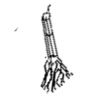 |  | 

3.Form words with letter sound “oo”
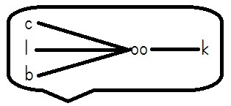
_________________________
_________________________
_________________________
_________________________
t

4.Chooseawordfromthelistanduseittofillthe gaps
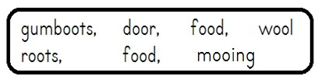
a. We eat______________to grow well.
b. Cow is to____________as bleating is to sheep.
c. The teacher asked Ruth to shut the____________
d. A sheep gives man____________and mutton.
e. We should wear____________on arainy day.
f.____________hold a plant firmly in the soil.
5.Read the poem below and answer the questions.
The moon
The moon! All round and very bright. I love you with all my heart.
You give me light at night
When darkness comes, I lookup the sky, to see your shape and
The beautiful stars
Written by Zoe

Questions
- What is the poem about?
__________________________________________________________
b. What gives the writer light at night?
________________________________________________________
- Why does the writer look up in the sky?
________________________________________________________
d. Who wrote the poem?
________________________________________________________

e. Draw and colour the moon and the beautiful stars.

6.Underlinewords with letter sound “oo”
a. The groom was smartly dressed in a suit.
b. Mukisa used a hook to catch fish from the pond.
c. We always go to the swimming pool on Monday.

